**MAAS**

- Pilih MAAS PROD

- Input User Name & Password

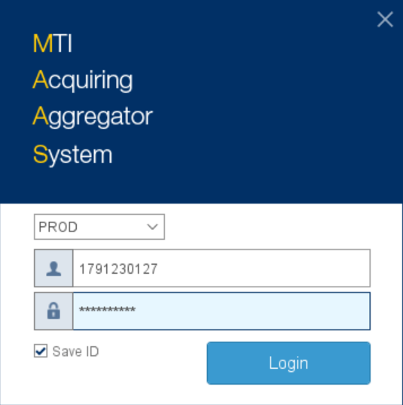

- Pilih field Merchant

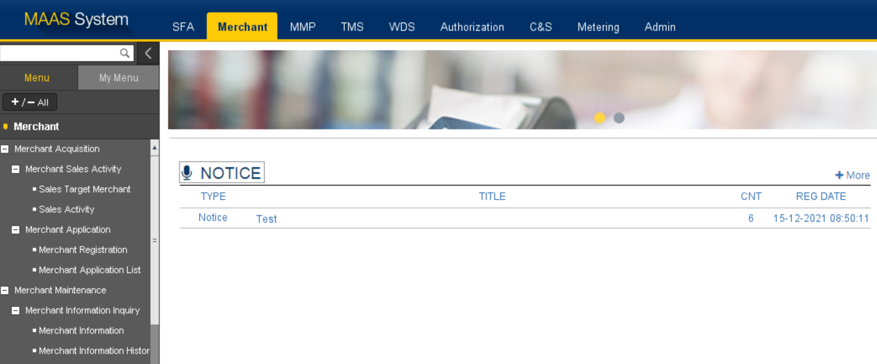

- Menu Sales Target Merchant, Tgl hari ini, Sales Status 🡪 Allocated, search

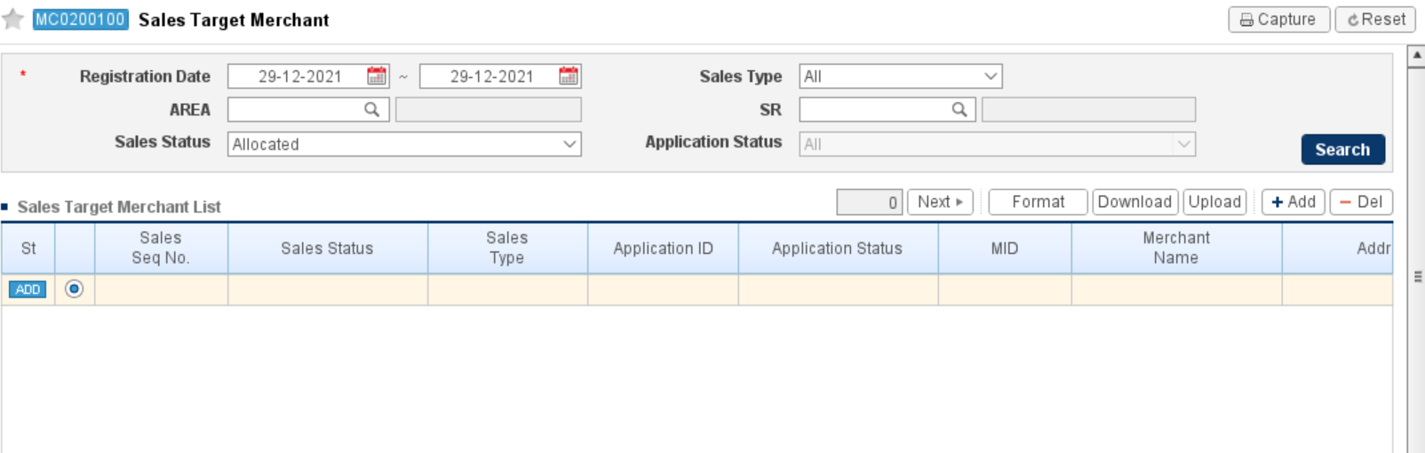

Klik add, Detail:

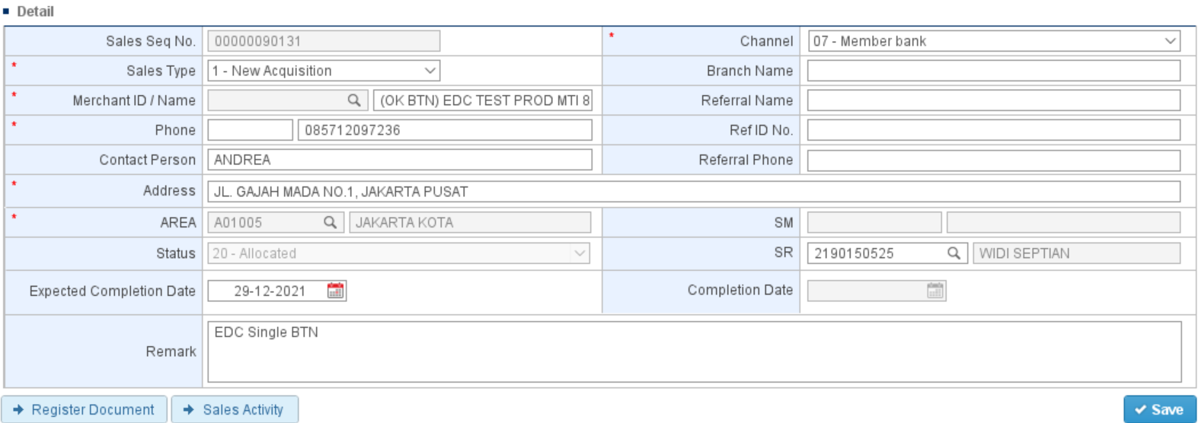

Sales Type : New acquisition

Channel : Member bank

Merchant ID /Name : (OK BTN) Nama Merchant

Phone, Contact Person, Address: Sesuai Data

Area : Pilih lokasi terdekat dengan alamat merchant

SR : Pilih / otomatis ter generate

Remark : EDC Single BTN

Save

Di Sales Target Merchant List di pilih merchantnya

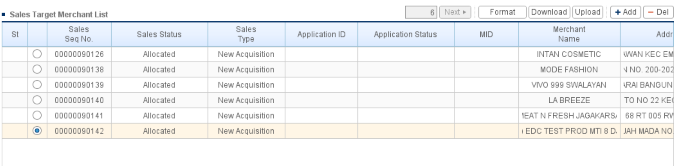

Sales Activity 🡪 klik nama merchant, add

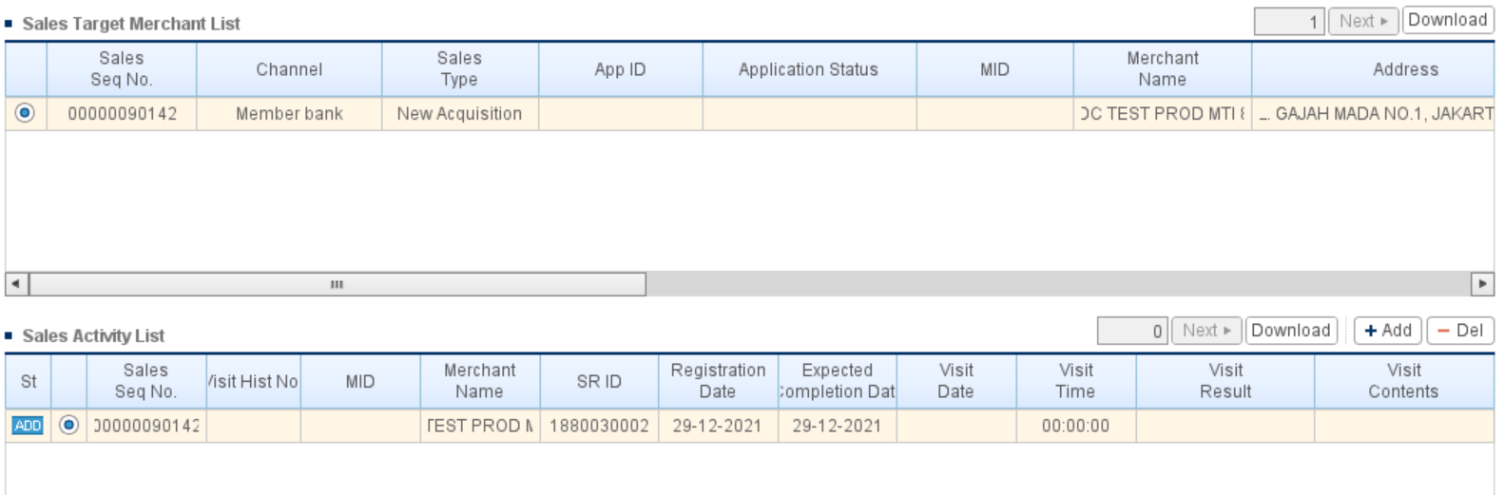

Visit Date : tanggal hari ini

Visit Result : Sales completed

Visit Content : OK

Save

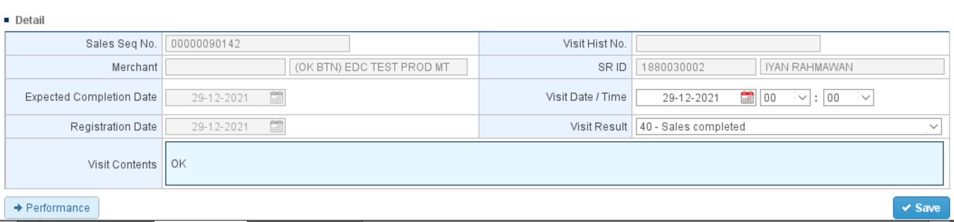

Kembali ke Menu Sales Target Merchant

Pilih Register Doc

Company Type : Member Bank

Attach dok Aplikasi Merchant, ID (KTP&NPWP), P&L, Foto Hasil OTS, Rekening Tabungan

Klik Add 3x :

1. Pilih 65-Other : File excel Field Mandatory
2. Pilih 68-QRIS PTEN : Surat Permohonan Merchant
3. Pilih 52-Form SID BI & Checklist : Checklist BI

Save

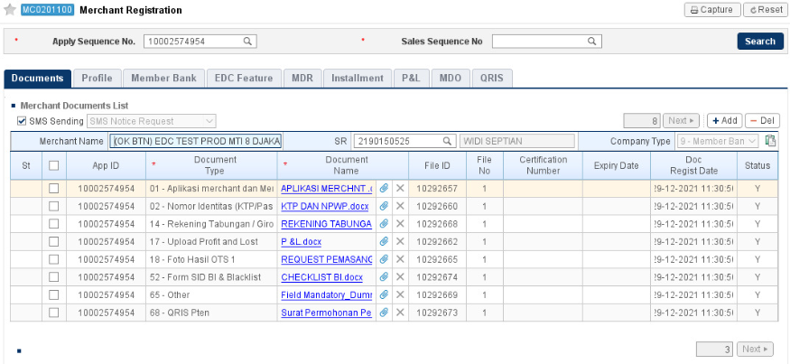

Submit

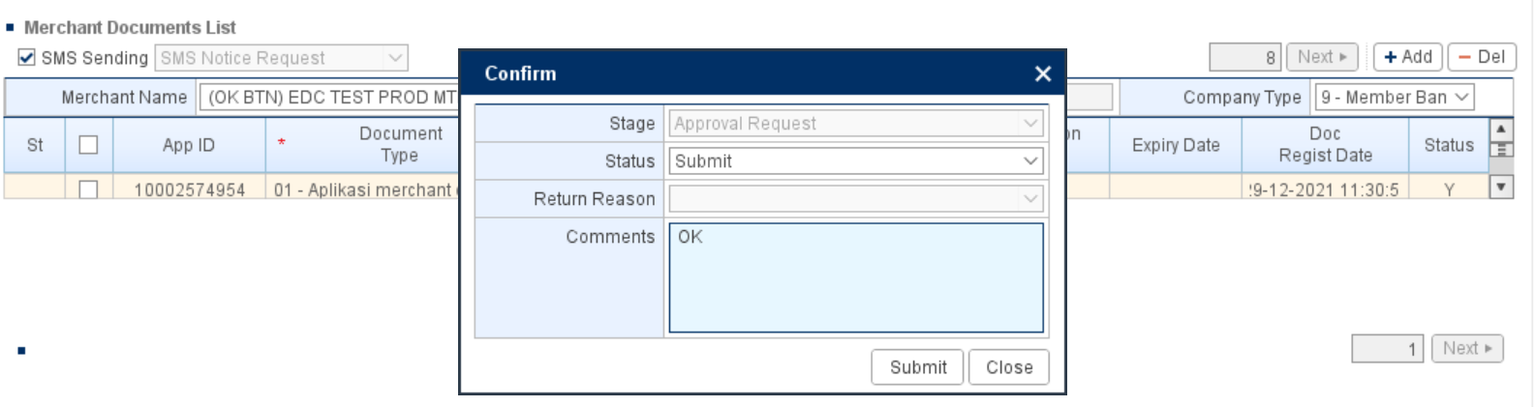

Submit



Note:

